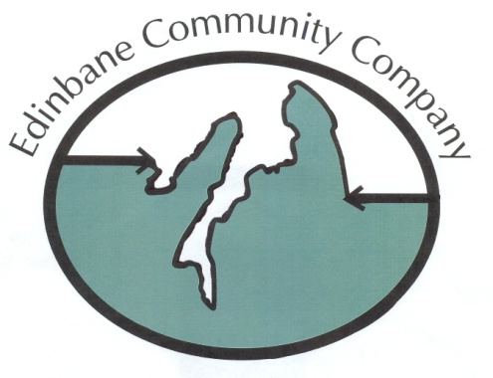
Small Development Grant Application Form – Max project cost £ 1,000

Personal Details of Applicant

Full Name (s) Family Name:

Address (inc post code)

Telephone
Mob
E mail

- Describe briefly the purpose for which funding is sought

Dates:

Location:

Total cost of Event:

- Please specify the amount requested with a breakdown of figures if appropriate. Please attached evidence associated with figures. Please note that the maximum grant available is £1,000

ITEM | Amount
TOTAL

- If other funding to support the activity is being sought / is already available, please give details.
Amount
Item | Amount | Agreed | Not agreed
TOTAL

- Please detail how the activity meets one or all of ECC “objects” as listed below in appendix 1 Guidance notes.

- Please provide details of a Referee, this cannot be a family relative.

Name:
Address:

Telephone No.
E Mail

Conditions:

Where possible quotes or clear evidence related to costs applied for in the grant should be attached to the application.

Applicants are required to sign the following statement as an indication that they Agree with the terms under which the grant is administered.

I accept that:

- The decision of the Directors of the ECC is final in respect of the application and that in the event of being refused there will be no further dialogue between myself and the Directors of ECC.

- In the event that I / the person on whose behalf this application is being made, do / does not complete the project for which support has been agreed I / the person on whose behalf this application is being made will
a) inform the Directors of ECC and
b) be prepared, if necessary, to repay a proportion or all of the monies awarded.

Signature Date
Appendix 1.

Guidance notes:

- Individual applicants must be 18 years or older at the time of the application. A parent or legal guardian of individuals under the age of 18 may make the application on their behalf.
- Individual applicants must be resident within the Edinbane Communities post code area that defines the area covered by ECC.
- In the case of an application on behalf of a person under the age of 18, that beneficiary must also be normally resident within the Edinbane Communities post code area that defines the area covered by ECC.
- Applicants are strongly advised to discuss any application with one of the Directors prior to submitting to the Board of Directors for consideration.

Objects of ECC

1.To manage community land and associated assets for the benefit of the Community and the public in general as an important part of the protection and sustainable development of Scotland’s natural environment, where ‘sustainable development’ means development which meets the needs of the present without compromising the ability of future generations to meet their own needs.

2.To promote the benefit of the inhabitants of the Community, without distinction on grounds of race, gender, political, religious, or other opinions, by associating with the local statutory authorities, voluntary organisations and inhabitants in a common effort to advance education. Further to provide direct financial support to any inhabitant or inhabitants of the Community (i) entering into tertiary education and /or (ii) for small community development type projects.

3.To provide, or assist in providing, facilities for recreation and other leisure time occupation for the benefit of the inhabitants of the Community, following principles of sustainable development and in the interests of social welfare so that conditions of life may be improved.

4.To advance the education of the Community about its environment, culture and/or history.

PRIVACY STATEMENT

Please tick the box below giving us permission to use the information you have supplied for the following purposes:
- To store it securely for membership purposes
- To communicate with you as an ECC member
- To send you general information about ECC or communications that we feel may be of interest to you
- Financial awards where appropriate
□ I consent to my data being used for membership purposes as detailed above.

Please be advised that you can request for your data not to be used for any of these purposes at any time by contacting the ECC at eccgdprenqs@gmail.com .

Please be assured that your data will not be used for marketing purposes or passed on to third parties.

You may, at any time, request a copy of your data from the address below.

Communications with you

I consent to the ECC contacting me for the above purposes by:

□ Post □ Email □ Phone Please tick all those that apply

ECC SMALL DEVELOPMENT GRANT ACCEPTANCE FORM

I………………………………………………………………….
agree to the conditions that the grant will be used exclusively for the purposes outlined in the application form and subsequent grant offer letter.

Please tick, as appropriate:

I accept the grant

I do not accept the grant as the grant is no longer required / funding has been secured via another source

Signature: Date:

Address:

THIS FORM MUST BE COMPLETED AND RETURNED WITHIN 14 DAYS OF THE DATE OF THE AWARD LETTER.

Please return the form to the Secretary:
Stuart Whatley (Secretary Treasurer)
Edinbane Pottery, Edinbane, Isle of Skye IV51 9PW 01470 582 234

